Name:_____________
Solar System Study Guide
Define on a new sheet of paper: asteroid, comet, meteoroid, astronomical unit, period of revolution, period of rotation, greenhouse effect
Fill in the blank:
There are millions of stars in each galaxy and billions of galaxies in the Universe.
If you were to travel to another planet your mass would stay the same. Your weight would change.
Objects that have more mass have a greater gravitational pull than objects with less mass. Objects that are closer together have a greater gravitational pull than objects farther apart.
Short Response ( on the paper you did vocab on)
1. What is the unit of distance used inside of the solar system called? What distance does it represent? Astronomical Unit/ AU. It represents the distance from the Earth to the Sun
2. What is the unit of distance used outside the solar system? Lightyear. What does that unit represent (the distance light travels in a year).
3. What is space mostly made up of?
Empty space
4. Are models of the solar system seen in textbooks accurate? Give at least two reasons to support your claim. The models are not to scale and are inaccurate because the sizes of the planets are wrong and the distances between them are way too small.
5. Draw four pictures showing the four stages of the formation of the solar system. Describe each picture with one sentence explaining what is happening.
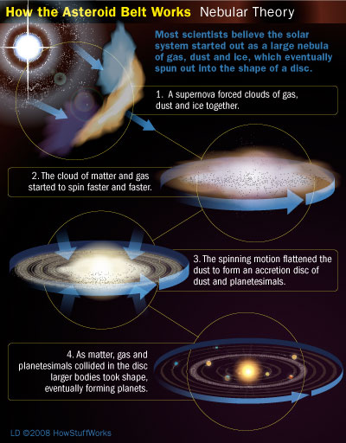
6. What is the current model of the solar system called? Why is it called that?
Heliocentric, it means sun-centered, and our solar system has the Sun at the center
7. What was the old model of the solar system called? Why?
Geocentric, Earth at the center, they believed the Earth was at the center of the Solar System
8. Why did the model change?
There was an overwhelming amount of evidence supporting the heliocentric model
9. Make a table that shows the moons and atmospheres of the four inner planets.
Planet | Moons | Atmosphere
Mercury | 0 | VERY THIN ALMOST NOT THERE
Venus | 0 | Mostly CO₂ and acidic sulfur
Earth | 1 | Nitrogen and oxygen
Mars | 2 small | Thin, mostly CO₂

10. What does an atmosphere do for a planet?
Atmospheres protect planets from debris, regulate temperature, protects from radiation of the Sun

11. Place these objects in order from smallest to largest:
star, solar system, planet, galaxy, asteroid, dwarf planet, universe
asteroid, dwarf planet, planet, star, solar system, galaxy, Universe
12. List at least two reasons why Pluto is no longer considered a planet.
Surrounded by similar sized objects, not like the other true planets around it, close in size to its moon, elliptical orbit, extreme temperature variations
13. List at least two pieces of evidence to support Accretion Theory (how the solar system was formed).
Planets orbit in the same direction and almost all revolve the same way, planets are on the same plane as the Sun, the inner planets are similar in composition to the Sun, the outer planets are similar in composition to each other
14. What is the shape of the orbits of the planets? Which direction do they orbit in?
Circular, counter clock wise
15. Differentiate between period of rotation and period of revolution. How long is Earth’s rotation? Its revolution?
Rotation: amount of time it takes a planet to spin on its own axis
Revolution: amount of time it takes a planet to go once around the Sun, its orbit
Earth rotation: 24 hours
Earth Revolution: 365.2 Days

