Scientific Method with SpongeBob Name: __________________________
Controls and Variables Date: __________________ pd : _____

I. Write a definition for each of the following words in YOUR own words. Yes look them up but don’t copy!
- Control –

- Variable –

- Independent variable –

- Dependent variable –

II. SpongeBob and his Bikini Bottom pals have been busy doing a little research. Read the following description for each of their experiments and answer the questions provided.

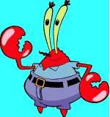
Krusty Krabs Breath Mints
Mr. Krabs created a secret ingredient for a breath mint that he thinks will “cure” the bad breath people get from eating crabby patties at the Krusty Krab. He asked 100 customers with a history of bad breath to try his new breath mint. He had 50 customers (Group A) eat a breath mint after they finished eating a crabby patty. The other 50 customers (Group B) also received a breath mint after they finished the sandwich, however, it was just a regular breath mint and did not have the secret ingredient. Both groups were told that they were getting the breath mint that would cure their bad breath Two hours after eating the crabby patties, 30 customers in Group A and 10 customers in Group B reported having better breath than they normally had after eating crabby patties.

1. Which group of people were in the control group?

2. What is the independent variable?
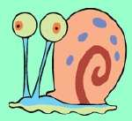
3. What is the dependent variable?

4. What do you think Mr. Krabs’ conclusion should be?

5. Give examples/details that support why you think in#4 what Mr. Krabs’ conclusion should be.

6. Why do you think 10 people in group B reported fresher breath?
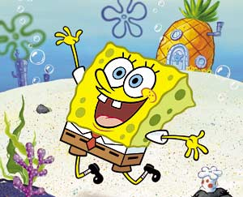
SpongeBob Clean Pants
SpongeBob noticed that his favorite pants were not as clean as they used to be. His friend Sandy told him that he should try using Clean-O detergent, a new laundry soap she found at Sail-Mart. SpongeBob made sure to wash one pair of pants in plain water and another pair in water with the Clean-O detergent. After washing both pairs of pants a total of three times, the pants washed in the Clean –O detergent did not appear to be any cleaner that the pants washed in plain water.

7. What was the problem SpongeBob wanted to investigate?

8. What is the independent variable?

9. What is the dependent variable?

10. What do you think SpongeBob’s conclusion should be?

11. Give examples/details that support why you think in #10 what SpongeBob’s conclusion should be?

Squidward’s Symphony
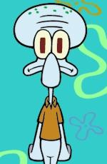
Squidward loves playing his clarinet and believes it attracts more jellyfish than any other instrument he has played. In order to test his hypothesis, Squidward played a song on his clarinet for a total of 5 minutes and counted the number of jelly fish he saw in his front yard. He played his song for a total of 3 times on the clarinet then repeated the experiment using a flute and then a guitar. He also recorded the number of jellyfish he observed before he began playing an instrument. The results are shown in the data table below.
Number of Jellyfish/Instrument
12. What is the independent variable?
Trials | No Music | Clarinet | Flute | Guitar
1 | 5 | 15 | 5 | 12
2 | 3 | 10 | 8 | 18
3 | 2 | 12 | 9 | 7

13. What is the dependent variable?

14. What do you think Squidward’s conclusion should be?

15. Give examples/detail as to why you think in #14 what Squidward’s conclusion should be?

16. Are the results reliable? Why or why not?

17. Any suggestions of what Squidward could have done differently to gain better results?
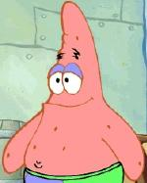
Super Bubbles
Patrick and SpongeBob love to blow bubbles! Patrick found some Super Bubble Soap at Sail-Mart. The ads claim that Super Bubble Soap will produce bubbles that are twice as big as bubbles made with regular bubble soap. Patrick and SpongeBob made up two samples of bubble solution. One sample was made with 5oz of Super Bubble Soap and 5oz of water, and the other was made with 5oz of regular bubble soap and 5oz of water. Patrick and SpongeBob used their favorite bubble wands to blow 10 different bubbles and did their best to measure the diameter of the bubbles as they popped on the table. The results are shown in the data table below.

18. What did the Super Bubble ads claim? Bubbles
(diameter in centimeters)
Bubble | Super Bubble | Regular Soap
1 | 15 | 10
2 | 10 | 5
3 | 12 | 16
4 | 18 | 14
5 | 22 | 11
6 | 13 | 12
7 | 16 | 11
8 | 18 | 15
9 | 15 | 15
10 | 12 | 6

19. What is the independent variable?

20. What is the dependent variable?

21. Look at the results in the data table.
- Calculate the average diameter for each bubble solution.
- Super Bubble = ____ cm
- Regular Soap = ____ cm
- What do you think SpongeBob’s and Patrick’s conclusion should be?

22. Are the results reliable? Why or why not?

