Name:____________________
8th Grade Science Midyear Study Guide
Answer all questions on a separate sheet of paper
Theories and Laws
- How do theories and laws differ?
  - Theories are explanations while laws are statements. A law is like a picture, it describes an event. A theory is like a caption to the picture, it explains what is going on.
- Can a theory become a law? Why or why not?
  - Theories are explanations, laws are statements. A theory is not a lesser version of a law. In the same way that a caption cannot become a picture, a theory can never become a law.
- Explain why theories may be modified but are rarely discarded?
  - Theories are built on a foundation of scientific knowledge. If some of that knowledge changes or is no longer accurate, the theory is still mostly relevant and must only be changed to accept the new information. To completely discard a theory, ALL the supporting evidence for the theory must be falsified.
- Why do we say that science is tentative and open to change?
  - With each new piece of technology, we can know and discover more. The more we know the more questions we can answer. Because of this, our answers are always getting better. What may be a great explanation now might not be sufficient in the future when newer and better technology allows us to answer a question from a different perspective.
Experimental Design
- Design an experiment. Identify the control variable, independent variable, and dependent variable.
  - A researcher wants to see if plants grow taller with loamy soil or sandy soil. She places 12 tomato plants in equal size pots and loads six witt 200g loamy soil and 6 with 200g sandy soil. She places them on the same ledge and waters them the same time each day. She measures the height of the plants daily.
    - IDV: soil type
    - DV: plant height
    - CV: pot size, plant type, water amount, soil amount, location, water schedule
- Why are control variables important?
  - Without control variables, you cannot know if your independent variable affected the dependent variable or if something else did.
- Why are control groups (groups that are not given the independent variable) important?
  - Control groups allow us to measure the effect of the independent variable against a group that did not receive any treatment. For example, one cannot say that drinking mountain dew makes people work harder if it was never measured how hard people work when not drinking mountain dew.
- What does replicable mean? Why do you think experiments need to be replicable?
  - Replicable means able to be repeated by another person. Experiments must be replicable so that others can peer review data from experiments.
- Is it bad to have an experiment turn out other than the way you expected? Explain.
  - No, there is always something to be learned from scientific inquiry.
- Differentiate between experiments and systematic observations.
  - Experiments: a plan is made, a variable is changed, and a response is measured. “How does X affect Y?” questions.
  - Systematic observations: a plan is made and then the researcher observes. “ What happens if?” questions.
Earth
- Why is Earth able to sustain life? (What things does it have that other planets don’t?)
  - Earth has water, an atmosphere, and is the optimal distance from the Sun.
- The surface of Mercury has many more craters than the surface of Earth. What does Mercury lack that Earth has to protect it from craters?
  - An atmosphere
- Differentiate between the geocentric and heliocentric model of the Solar System. Which is correct?
  - Geocentric: Earth at the center
  - Heliocentric: Sun at the center, this is correct.
- Why does Earth experience Seasons?
  - The Earth is tilted on its axis. As it revolves around the Sun, the part of Earth tilted toward the Sun receives the most direct sunlight, a higher concentration of light, and thus a higher temperature. Higher temperatures cause summer. The inverse is true for the hemisphere facing away from Earth. During the equinoxes, each hemisphere receives an equal amount of sunlight.
- What order do the Seasons move in?
  - Winter to Spring to Summer to Fall back to Winter in a cycle
- Why do we see phases of the moon?
  - We see phases of the moon because as the Moon revolves around Earth the portion of the lit up side of the Moon that we are able to see from our perspective changes. The amount of the moon actually lit up does not change.
- Draw and label the phases of the moon.
  - 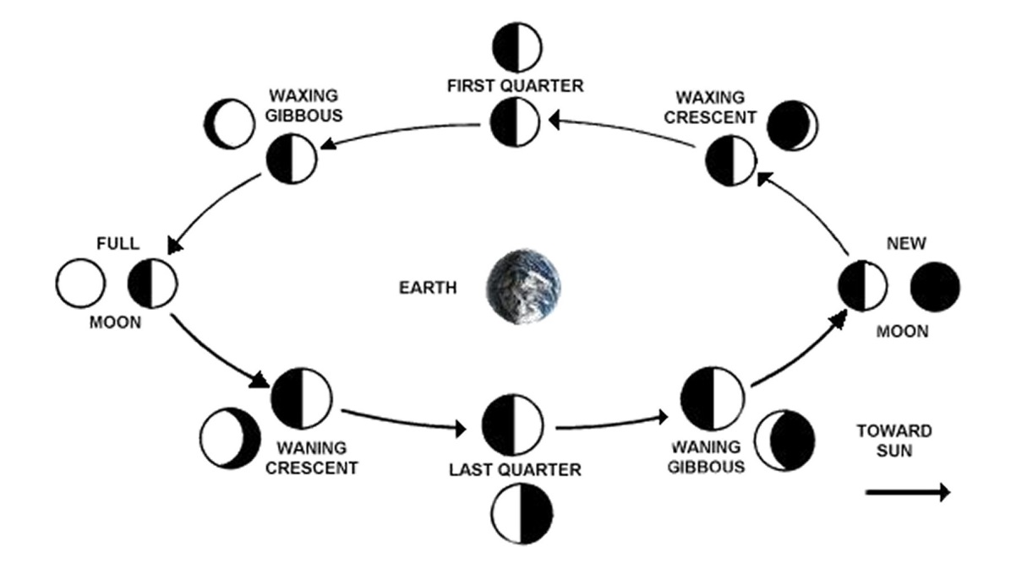
Solar System
- Alpha Centauri is the closest star outside of our Solar System. What unit would we use to measure the distance to Alpha Centauri?
  - Light years
- What is a light year and where is it used?
  - It is the distance light travels in a year. It is used to measure distances outside of the solar system.
- What is an AU and where is it used?
  - An astronomical unit, the average distance from the Earth to the Sun. It is used to measure distances between planets and objects in our own solar systems.
- Write the planets in order. Circle the rocky planets, draw squares around the gaseous planets.
  - Rocky inner planets: Mercury, Venus, Earth, Mars
  - Gaseous outer planets: Jupiter, Saturn, Uranus, Neptune
- What force causes planets to orbit the Sun?
  - gravity
- What is the shape of all planets? Why are they shaped that way?
  - Sphere, gravity pulls everything towards the center of mass, creating a sphere.
- What is the shape of the orbits of the planets? (Use the REAL science term, check your book)
  - Elliptical
- How did gravity affect the formation of the Solar System
  - In a nebula, matter condensed in the center because gravity pulled gas and dust together in areas of higher mass. This caused the nebula to spin counter clock wise. The process continued with more gas and dust collapsing around areas of greater mass forming planetessimals.
Space
- What are the three shapes of galaxies?
  - Irregular, elliptical, spiral
- There are billions of galaxies, each containing billions of _____stars_________.
Stars
- Define apparent magnitude and absolute brightness.
  - Apparent magnitude: a measure of brightness as seen by an observer on Earth
  - Absolute Brightness: the total amount of light produced by a star regardless of its distance from an observer
- Draw a picture that shows the colors of stars from hottest to coldest.
  - 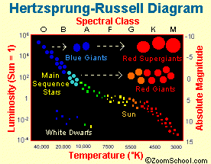
- Why might a star that is VERY bright, but far away appear less bright to us than a star with low brightness that is very close?
  - Its apparent magnitude is less than its absolute magnitude/brightness
- What are satellites and what are they used for?
  - Satellites are any small object that orbits another body, besides a star. We use man-made satellites for a variety of things. For example, telecommunications, GPS, photography etc.
- How does light travel?
  - In waves.
- Is all light in the form of visible light?
  - NO. There are MANY forms of light we can’t see.
- What other uses do light waves have?
  - Microwaves, radiowaves, X-rays, infrared detection.
- What kind of waves are used to make a microwave work?
  - microwaves

