Name:_______________
Chapters 9 and 10 Assessment Study Guide
- Why don’t cells simply grow larger in size to increase the size of an organism?
  - Cells have a “carrying capacity” of size. If the cell gets too large, it can no longer perform cell functions correctly because there is just too much space to transport over. This would slow hormone responses and would also affect passive and active transport. Also the plasma membrane cannot regulate a cell that large (see below).
- What is the importance of the ratio of surface area to volume of a cell?
  - The greater the ratio of surface area to volume of a cell, the more efficient it is at removing waste, transporting hormones and other necessities and generally functioning. As a cell’s size increases, the ratio of SA to volume decreases, putting more strain on the cell.
- Draw and label a picture of the cell cycle (see p.246). Explain what is happening in each phase besides mitosis.
  - 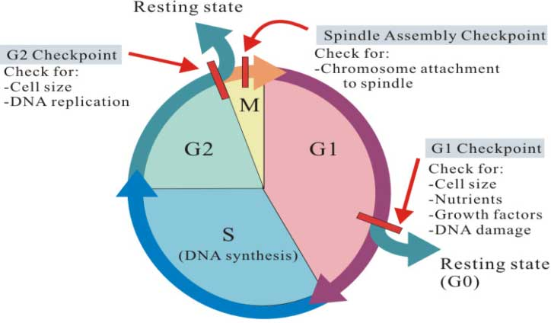
- Draw a chromosome and label the following: chromosome, chromatid, centromere.
  - 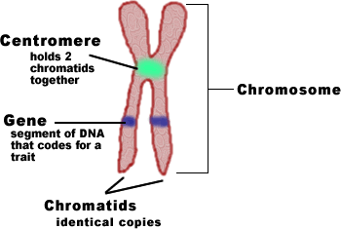

- Draw the steps of mitosis. Provide bullet points for what is happening at each step.
  - 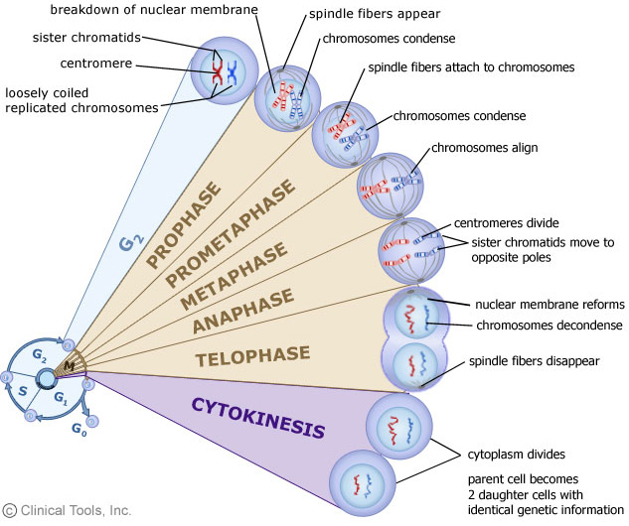
- What is the role of cyclins in the cell cycle? If there were no cyclins, what might happen?
  - Cyclins act as checkpoints for the cell cycle. If everything is going correctly, a specific cyclin protein will bind with a CDK (an enzyme). This will allow the cell cycle to continue. If it doesn’t occur, the cell cycle will stop. This prevents damaged cells from growing and replicating, passing on damaged DNA. If there were no cyclins, an organism might have a lot of damaged cells and not be able to function.
- At the cellular level, what is cancer? How does the body destroy cancerous cells?
  - Cancer is uncontrolled cell growth that occurs when cells grow and divide unchecked and rapidly. The body keeps cancer from occurring most of the time through apoptosis: programmed cell death.
- Differentiate between adult and embryonic stem cells.
  - Adult stem cells are less able to differentiate into different types of cells. Also adult stem cells are more likely to have mutations.
- What is produced by meiosis?
  - Four haploid and genetically different daughter cells.
- Draw the process of Meiosis. Explain each phase in bullet points.
  - See page 273, your textbook has the best picture.
- What is crossing over and when does it occur? Why is it beneficial to a species?
  - Crossing over is the exchange of genetic information that occurs between homologous chromosomes in prophase I. Crossing over usually occurs between genes that are far apart from each other and are on different chromatids.
- What are the benefits of meiosis?
  - Meiosis provides the genetic variation necessary for the adaptation and survival of a species. If there were no meiosis, all organisms of a species would be very similar. Because of this there would be a greater potential for whole species to perish because of diseases or disorders that would affect each organism the same.
- Compare and contrast mitosis and meiosis.
  - Mitosis begins with a diploid somatic (body) cell and ends with two identical diploid somatic cells. Meiosis begins with one diploid germ (sex) cell and ends with four haploid and genetically different daughter cells.
- Explain what Mendel saw in the F1 generation. What did he then try to figure out?
  - Mendel saw only yellow pea plants. He then tried to determine whether the green trait had disappeared or was simply masked.
- What is an allele and how does it relate to a gene?
  - An allele is a copy of a gene. For example, you have a gene for hair color, but you have many alleles, copies, of this gene from your mother and your father. Those copies are different.
- Differentiate between: heterozygous and homozygous, genotype and phenotype, dominant and recessive. Heterozygous means both alleles, homozygous means the same alleles. Genotype is the alleles an organism has, phenotype is the outward expression of those alleles. Dominant traits are expressed while recessive traits are hidden.
- Explain Mendel’s Law of Segregation.
  - Alleles for a trait separate during meiosis.
- Explain Mendel’s Law of Independent Assortment.
  - During meiosis, alleles are distributed randomly.
- What is genetic recombination and how does it impact genetic diversity?
  - The new combination of genes caused by crossing over and independent assortment is genetic recombination. The more chromosomes a species has, the greater genetic recombination is possible. Genetic recombination is the reason for genetic diversity. It ensures that there are so many genetic combinations that it is unlikely to ever have exactly the same one. For example, there are more than 70 trillion combinations of human alleles.
- A species of super cute unicorns are either pink or blue. Blue is the dominant trait and some of the pink unicorns tend to get bullied because they are weird. A pure blue unicorn mates with a heterozygous unicorn. What are the chances that their unicorn foal will be pink?
  - 0%. This unicorn family can rest assured that their children will never be stuffed in a trashcan or otherwise shunned for their pink coats (which is discrimination and is looked down upon).

 | B | B
B | BB | BB
b | Bb | Bb

- These particular unicorns have been involved in an eon’s long war with the neighboring trolls. As a result, they have evolved flight. Some unicorns are able to fly by spinning their tails like a helicopter and others have evolved wings. Heli-tails are dominant and wings are recessive. A homozygous blue heterozygous heli-tailed female mates with a pink winged male. Predict the probability of those two alicorns having a foal heterozygous for both traits.

- Genotypes of parents: Mom: BBFf Dad: bbff
- Possible gametes produced by parents: Mom: BF, Bf Dad: bf
- Punnett Square
 | bf
BF | BbFf
Bf | Bbff

½ or 50% probability of having a heterozygous foal.

