Name:____________________
Matter Study Guide
- Define the following terms:
Mass: a measure of how much matter is in an object
Volume: a measure of how much space an object takes up
Matter: anything that has mass and takes up space
Atom: the smallest unit of matter (there are parts of an atom but the atom is the smallest thing that can be defined as a certain kind of matter
Molecule: two or more atoms bonded together
Density: a measure of how much matter is in a unit of volume, a measure of how compact the molecules in a substance are
- Finish the table below:
 | Solid | Liquid | Gas
Volume and Shape | Definite volume and shape | Definite volume indefinite shape | Indefinite volume and shape
Movement of molecules | vibrate | Slide past each other | Bounce off of each other
Energy | least | middle | most
- Draw a picture of the molecules in a solid, liquid, and gas. Show how they are moving and provide a caption for each picture that explains how the molecules are arranged and how they move.
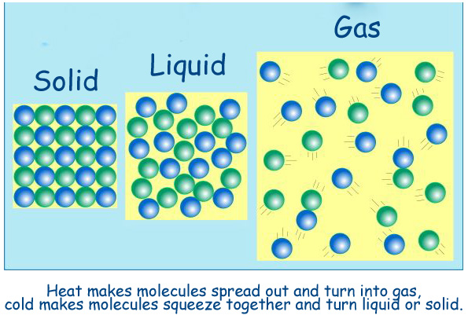

- Explain what happens to the molecules in a substance as it heats up.

Heat causes molecules in a substance to speed up and move more quickly. It also causes the molecules to move apart from each other.
- Explain what happens to the molecules in a substance as it cools.
Absence of heat causes molecules to slow down and move less. Also, attraction between the molecules increases.
- How does a liquid thermometer work? Use the words molecules, expansion, contraction, move, heat and cool in your answer.
As the liquid in the thermometer heats up, the molecules begin to move faster and apart from each other, causing the liquid to expand. When it cools, the molecules move slower and are more attracted to each other, causing the liquid to contract.

- Explain why a metal ball that is made to fit through a metal ring will no longer fit through when the ring is frozen and the ball has been heated. Use the words molecules, expansion, contraction, move, heat and cool in your answer.
As the ball is heated, the molecules in the ball move more rapidly and are less attracted to each other. As a result, the ball expands. The molecules in the ring , however, are cooled and slow down. They also move closer together, causing the ring to contract.

- Write each state of matter and connect them all together with arrows. Over each arrow explain the process that occurs to change the matter from one phased to the other. For example, the arrow from solid to liquid would be labeled melting.

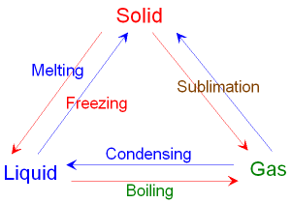 WEUSE VAPORIZATION, NOT BOILING!

- Explain what density is a measure of and draw a picture of a dense object and an object that is less dense.
Density measures how much matter there is for each unit of volume in a substance. Really, it’s measuring how compact the molecules are.

Answer the following on your own sheet of paper. Show all work.
- A cube has a length of 3cm and a mass of 180g. What is the density of the cube? Show all work.
- V= l*w*h
- V=3cm*3cm*3cm
- V= 27cm³
- D= m/v
- D= 180g/27cm³
- D=6.7g/cm³
- A rectangular prism has a length of 2cm, a width of 1 cm, and a height of 3 cm. It has a mass of 100g. What is the density of the prism? Show all work.
- V=l*w*h
- V=2cm*1cm*3cm
- V=6cm³
- D=m/v
- D = 100g/6cm³
- D= 16.7g/cm³
- A liquid is placed in a graduated cylinder. The cylinder reads 60mL. The mass of the cylinder is 40g. Together, the liquid and the cylinder have a mass of 100g. What is the density of the liquid?
- Mass of cylinder and liquid – mass of cylinder = mass of liquid
- 100g-40g= mass of liquid
- Mass of liquid = 60g
- D = m/v
- D = 60g/ 60 mL 60mL is the volume from the cylinder. We don’t need to do math for this.
- D= 1g/mL
- What do you think the liquid in 12 might be? Why?
The liquid is probably water, which has a density of 1 g/mL
- Be SURE you know how calculate the volume and mass of any object we have used in class. Practice. You will be asked to do this on the test.

