Name:
Carbohydrate Modeling Lab
- Use a marshmallow to represent a carbon atom.
  - How many bonds is carbon able to form? ______
  - If you use toothpicks to represent bonds, how many should you place in your marshmallow?
- Choose a gum drop color to represent hydrogen:__________.
  - How many bonds can hydrogen form?________.
  - If hydrogen bonds to a carbon atom, how would you model that with gum drops, toothpicks, and marshmallows? Refer to question 1 b to see the maximum amount of toothpicks your carbon atom can hold.
- Choose a gum drop color to represent oxygen:__________.
  - How many bonds can oxygen form?________.
  - If oxygen bonds to a carbon and hydrogen atom, how would you model that with gum drops, toothpicks, and marshmallows?

- 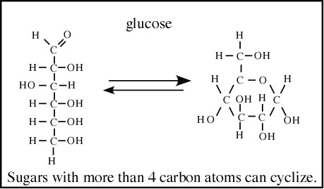This is glucose, because glucose has more than 4 carbon atoms, it can “cyclize” or take a ring shape. Model the ring-shaped glucose using your gum drops, toothpicks, and marshmallows. Be sure your model has the same number of atoms as the picture!

- 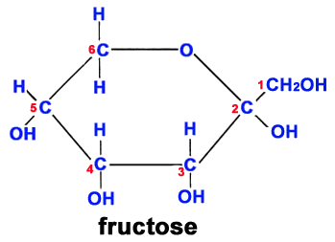This is fructose, because fructose has more than 4 carbon atoms, it can “cyclize” or take a ring shape. Model the ring-shaped glucose using your gum drops, toothpicks, and marshmallows. Be sure your model has the same number of atoms as the picture!

- 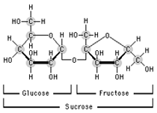This is sucrose. It is a polymer formed from the monomers glucose and fructose. Page 168 of your book also has a picture of sucrose. Using your glucose and fructose models, create a model for sucrose. Remove any atoms you no longer need and place them aside. DO NOT EAT THEM. After you have made your model, look at your model, leftovers, and book to answer the following questions.
  - Which atoms did you have to remove to make sucrose?

  - What other molecule that you are familiar with could you make with these molecules?

