Chapter 15 Outline
Answer each question and define or explain each concept
- What did Darwin do on the Beagle?
He was a naturalist.
- What did Darwin notice about the animals in the Galapagos?
They were similar but each island had its own slightly different variety of animal.
- What did Darwin hypothesize?
He hypothesized natural selection, like artificial selection but in nature.
- What are the four principles of natural selection?
  - Variation, Heritability, Overproduction, Reproductive advantage
- Darwin’s theory of natural selection is not synonymous with _____________________.
  - evolution
- Natural selection is a way of: explaining how evolution works.
- Evidence for Evolution
  - The Fossil Record
    - Derived Traits: new features not in fossil record
    - Ancestral Traits: features in fossil record
    - Homologous Structures: similar structure, different function
    - Vestigial Structures: reduced forms of functional structures in other organisms
    - Analogous Structures: same function different form
  - Embryology: vertebrate embryos look very similar to each other and have homologous features that end up as completely different structures in the fully formed organism. Animals that are more closely related share more similarities and look more similar for longer.
  - Comparative Biochemistry: Many organisms share similar DNA make-up. The more metabolic molecules the organisms share, the more closely related they likely are. Organisms that look similar also have similar molecular makeup.
  - Geographic Distribution: Migratory patterns influence evolution. The distribution of animals over certain areas can help to determine species. Also, in areas such as Australia, marsupial animals look very similar to the placental animals of north America and Europe. Despite the fact that Australia was isolated from those areas, marsupial animals evolved to have similar features to fill similar niches long before humans got there. More complex placental mammals were not found on Australia until the arrival of humans.
- Adaptation: a trait shaped by natural selection that increases an organism’s reproductive success. NOT an animal working better in its current environment.
  - Fitness: a measure of how effective a trait is at allowing an animal to reproduce and pass on the trait
  - Camouflage: organisms blend in with their surroundings
  - Mimicry: organisms look like another species to avoid predation
  - Consequences of adaptations: some do not necessarily increase reproductive success
- Mechanisms of Evolution
  - Population Genetics
    - Hardy-Weinberg: a population is in genetic equilibrium if the frequencies of the alleles in the population remain constant
      - P²= homozygous dominant frequency
      - 2pq = heterozygous frequency
      - Q²= homozygous recessive frequency
    - Genetic Drift: change in the alleles of a population due to chance. This affects small populations most. Ex: if a hurricane killed all but a few of the animals that carried a specific allele for a trait, that trait would be lost from the population forever if it was not passed from those three individuals. This changes the population.
    - Founder Effect: When a small part of a population settles in a new area, alleles that weren’t common in the old population may be more common in the newer smaller one. Ex: Amish people have many rare genetic disorders, some so rare they’re not even named. A small number of the Amish settled in America originally, and they tend to only marry other Amish, so there is not much genetic variation among them.
    - Bottleneck: When a population declines and then rebounds, it is build back up with very limited alleles.
    - Gene Flow: when genes transfer from one population to another. This increases genetic variation in the populations. Ex: Two flower populations are separated and do not interbreed. Bees bring pollen from one population to the other, increasing diversity.
    - Non-Random Mating: animals are attracted to specific features, this leads to inbreeding and a change in allelic proportions.
- Natural Selection Types (explain and draw graphs)
  - Stabilizing Selection
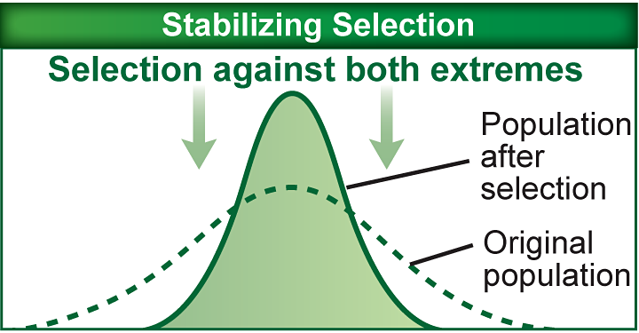
  - Directional Selection
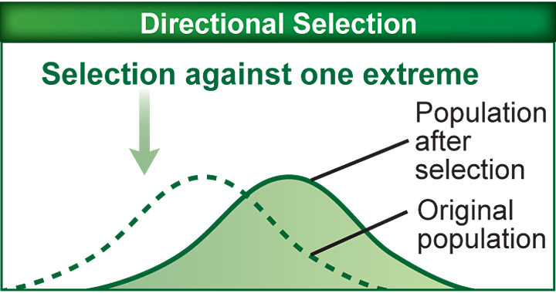
  - Disruptive Selection
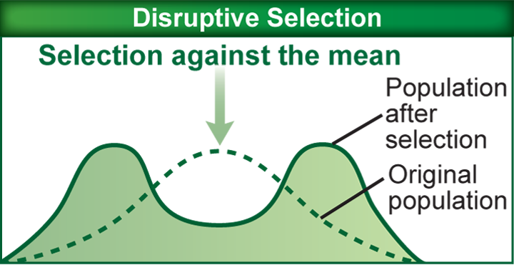
  - Sexual Selection : animals with certain features are more likely to reproduce, some of these qualities might be opposite of qualities that enhance survival. Males and females usually look very different Ex: cardinals and peacocks
  - Pre-Zygotic Selection: prevents reproduction by making fertilization unlikely. Usually different locations, behavior, or ecology.
  - Post-Zygotic Selection: animals born as a result of inter species mixing are sterile.
- Speciation NOT ON THIS TEST
  - Allopatric Speciation
  - Sympatric Speciation
  - Adaptive Radiation
  - Coevolutuion
  - Convergent Evolution
  - Rate of Speciation
    - Gradualism
    - Punctuated Equilibrium

