Chapter 8 Study Guide

1. What are the inputs and outputs of photosynthesis? I.E. What is the equation?

6CO2 + 6H2O 🡪 C6H12O6 + 6O2

1. How is energy from photosynthesis used in cellular respiration?

Glucose profuced in photosynthesis is used in cellular respiration to create ATP energy.

1. Differentiate between heterotrophs and autotrophs.

Heterotrophs require energy obtained from food, autotrophs can make their own energy from the Sun

1. Label the following diagram
2. Light B. H2O C. light reactions D. O2  E. ATP F. NADPH G. CO2 H. Calving Cycle I. Glucose

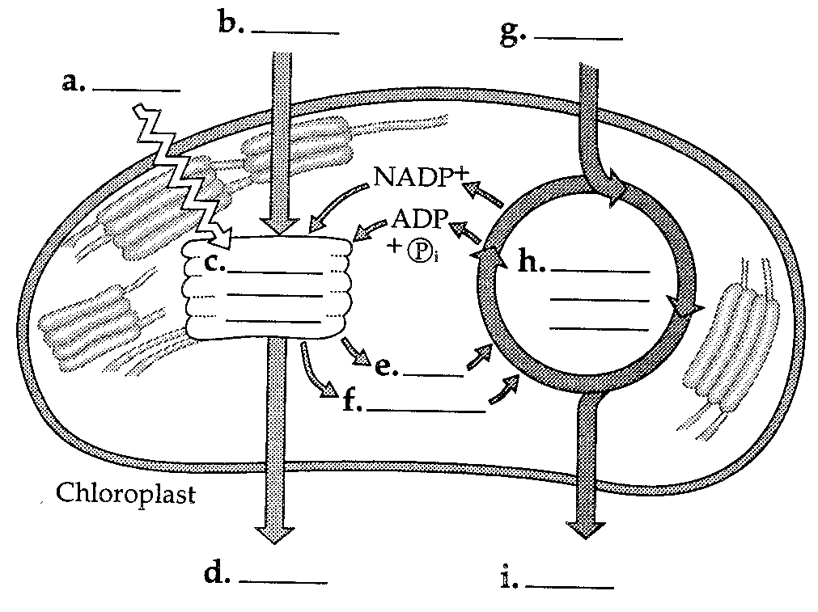

1. Explain how ATP is used in photosynthesis. How is energy stored in ATP?
   1. ATP is used to alter molecules used in the Calvin Cycle,

1. Where in the picture below is energy released? Where is it stored?

It is released at Step 3 and stored at Step 1.



1. What does the Calvin Cycle require from the light-dependent reactions?

The Calvin Cycle uses the ATP and NADPH from the light reactions.

1. Why shouldn’t we call the Calvin Cycle the dark reactions?

That name implies that they only take place at night. In reality, they simply do not require the sunlight.

1. Why does chlorophyll appear green? Why won’t plants grow well in green light?

Chlorophyll appears green because it absorbs all wavelengths of light except green, which is reflected back to our eyes, making it appear green.

1. What is the equation for cellular respiration?

C6H12O6 + 6O2 🡪 6CO2 + 6H2O + ATP

1. Where does cellular respiration occur?

Cellular respiration occurs in the mitochondria, although glycolysis, a step, occurs in the cytoplasm because they enzymes required for glycolysis are located there.

1. List and explain the steps of cellular respiration.

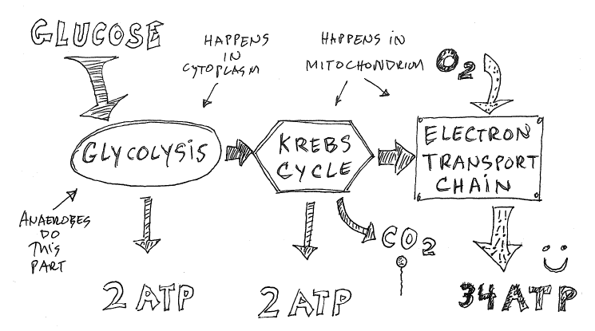

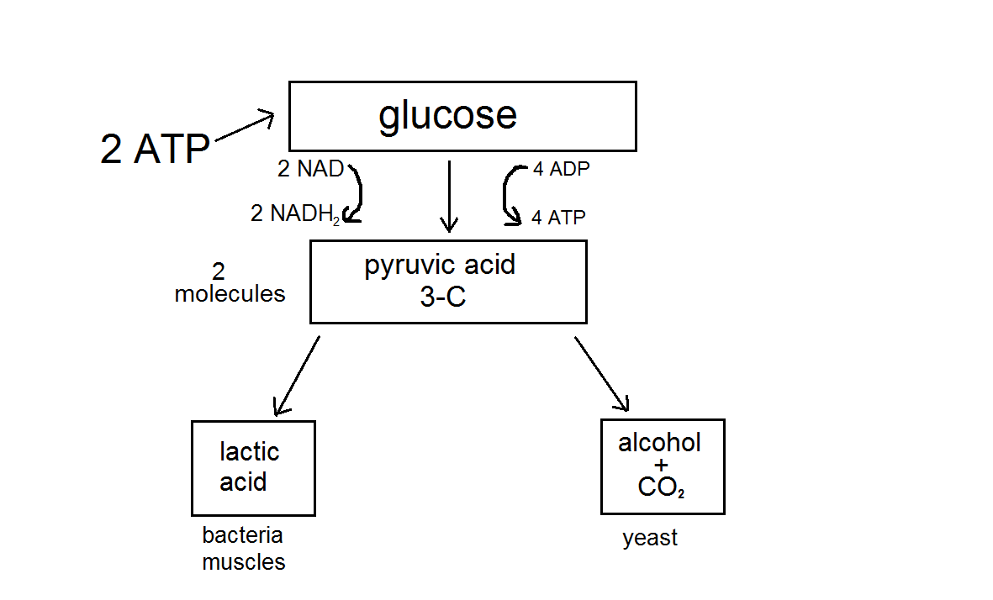

1. What molecules are the electron carriers for cellular respiration?

NAD + and FAD are the electron carriers. They turn into NADH and FADH2

1. Differentiate between aerobic and anaerobic respiration. Which is more efficient?

Aerobic respiration occurs in the presence of oxygen and includes the Kreb’s cycle and also the electron transport chain, which turns the ATP-Synthase motor. Anaerobic respiration occurs without oxygen and, because it cannot operate ATP synthase, is less efficient.

1. Explain the two different types of fermentation.

Lactic acid fermentation occurs in human muscle cells with a lack of oxygen. It produces lactic acid. Alcoholic fermentation occurs in yeast/ microorganism cells with no oxygen and produces ethanol and CO2.

1. Explain why it is said that photosynthesis and cellular respiration are cyclical.

The products of one are the reactants for the other.

