Chapter 8 Study Guide

1. What are the inputs and outputs of photosynthesis? I.E. What is the equation?
2. How is energy from photosynthesis used in cellular respiration?
3. Differentiate between heterotrophs and autotrophs.
4. Label the following diagram

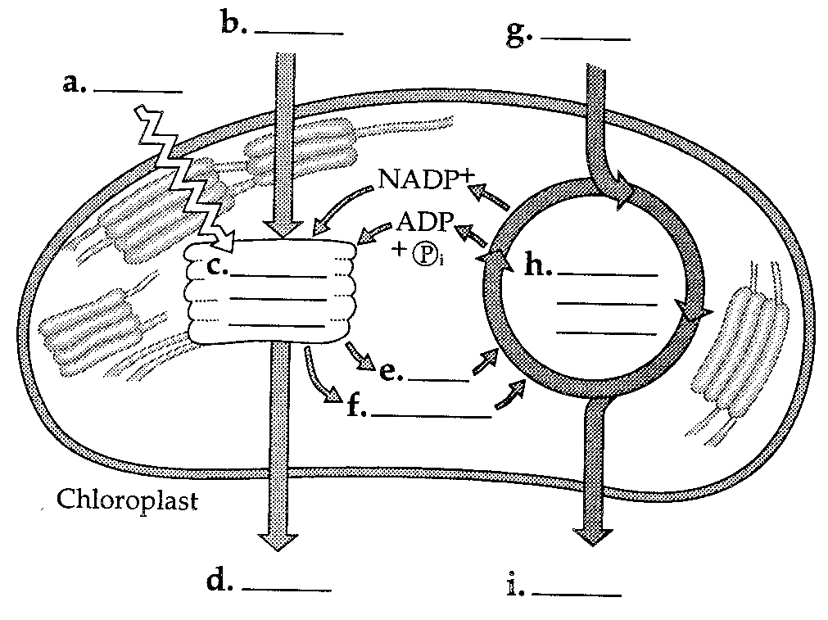

1. Explain how ATP is used in photosynthesis. How is energy stored in ATP?
2. Where in the picture below is energy released? Where is it stored?



1. What does the Calvin Cycle require from the light-dependent reactions?
2. Why shouldn’t we call the Calvin Cycle the dark reactions?
3. Why does chlorophyll appear green? Why won’t plants grow well in green light?
4. What is the equation for cellular respiration?
5. Where does cellular respiration occur?
6. List and explain the steps of cellular respiration.
7. What molecules are the electron carriers for cellular respiration?
8. Differentiate between aerobic and anaerobic respiration. Which is more efficient?
9. Explain the two different types of fermentation.
10. Explain why it is said that photosynthesis and cellular respiration are cyclical.