Chapter 11 Study Guide
For Questions 1-9, use the pedigree chart shown below. Some of the labels may be used more than once.
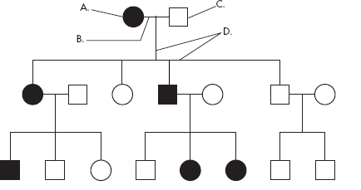

____C___ 1. A male
A 2. A female
___B_____ 3. A marriage

A 4. A person who expresses the trait
C 5. A person who does not express the trait
D 6. A connection between parents and offspring

__3______ 7. How many generations are shown on this chart?

8- 11. Identify the following pedigrees as autosomal or sex linked AND as dominant or recessive.
(Look at whether an equal number of males and females have the disease. If the chances seem equal it’s probably autosomal unless you can see a specific situation that suggests otherwise. If two unaffected parents have affected children it is probably recessive. If to affected parents have ALL affected children it is probably recessive. If two affected parents have children without the disorder it is dominant. )

Autosomal recessive
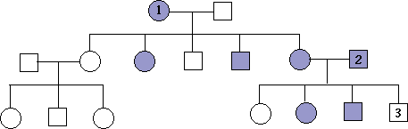
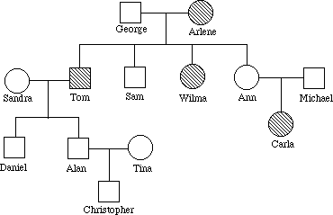
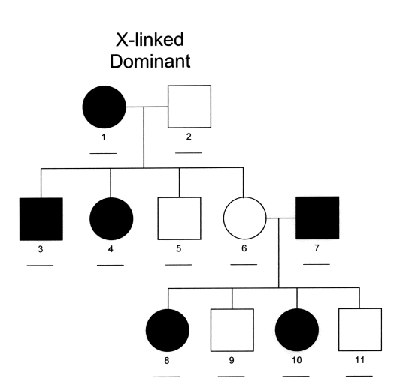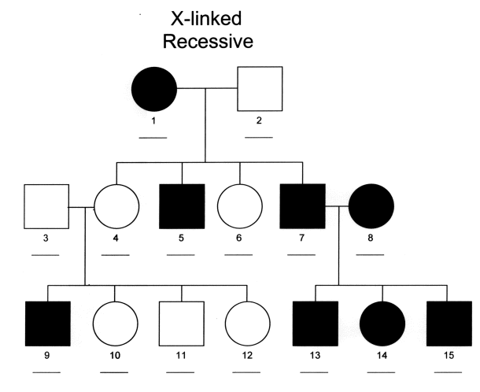

Autosomal Dominant

12. Why is polyploidy important in agriculture?
Polyploid plants have multiple copies of genes and are extremely genetically robust because they are less likely to inherit defects that can’t be masked.
13. Give two examples of recessive genetic disorders and explain how they affect the afflicted person.
Tay-Sachs: fatty build up in brain, death by 5. Cystic Fibrosis: Mucus build up in lungs, death by 30
14. Give two examples of dominant genetic disorders and tell how they affect the afflicted person.
Achondroplasia: short arms and legs, big head, normal life span. Huntington’s: motor control issues, mental decline, symptoms between 30-50, worse in each generation until the last person dies too young to reproduce.
15. Differentiate between incomplete dominance and co-dominance, give examples of each.
Incomplete dominance creates a NEW BLENDED PHENOTYPE. White flower x red flower= pink flower
Codominance: BOTH ALLELES ARE EXPRESSED. White flower x red flower = white flower with pink spots, ABO blood typing in humans
16. Explain how multiple alleles affect the coat color of rabbits.
C > c^{ch} > c^{h} > c. 10 possible genotypes with four possible phenotypes. Multiple alleles means MORE GENETIC VARIATION.
17. Explain epistatis. How does it affect Labrador dogs?
Labs have two genes affecting color: E and B. The "E" allele determines whether or not dark pigment will be in the fur (E = pigment present e=pigment not present) the "B" allele determines how dark that pigment will be. bb=chocolate brown. B= black. If the dominant E allele isn’t present, it doesn’t matter if the B allele is there or not, the dog will have a light coat. The e allele masks the effect of the dominant B allele.
18. Why do males have a greater chance of inheriting sex-linked disorders?
Males inherit only one X chromosome. If a male receives an X chromosome that carries a recessive gene for a disorder, he will not receive the dominant gene to cover it up. Thus, the recessive disorder will be expressed.

19. How do cells in females account for having two X chromosomes?
In female cells, one X chromosome is inactive so that the person does not receive a “double dose” of X chromosome genes. This inactive chromosome is called a Barr Body.
20. What is a polygenic trait?
Traits that arise from the interaction of multiple genes are polygenic. The intermediate phenotypes are much more common and all the phenotypes tend to follow a bell curve.
21. Polygenic traits usually cause certain phenotypes to be common and others to be rare. Draw a picture of this inheritance pattern or explain in words.
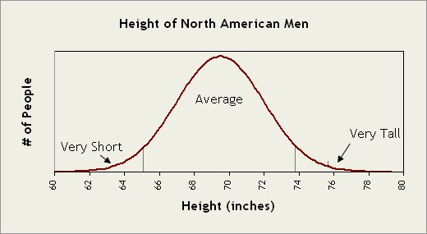
22. What is a karyotype?
A karyotype is a picture of someone’s chromosomes. They are used to determine genetic disorders.
23. How does non-disjunction occur?
Nondisjunction occurs when chromosomes fail to separate in either meiosis 1 or meiosis 2.
24. Draw a picture that shows how a child might end up with trisomy X(XXX) syndrome due to a nondisjunction event. Where could non-disjunction occur?
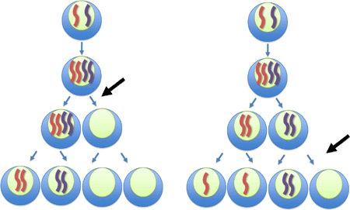
If these two situations were to happen in the MOTHER, the resulting gametes (first two on the left, third one in on the right) could have XXX syndrome if fertilized by an X chromosome from the father.

