Name:________________
Chapter 12 Study Guide
- What experiments discussed in your book contributed to the discovery of DNA? Describe each experiment or discovery and the importance of each.
Griffith: R and S strain bacteria injected into mice. Saw that S strain quality of killing mice could be passed to “safe” R strain bacteria even after S strain was dead. Suggested there was a genetic material.
Avery: isolated the macromolecules in S strain bacteria and exposed each to R strain to see what transferred S strain qualities to R strain bacteria. Concluded that DNA was the genetic material. Was contested by other scientists who weren’t sure if it was DNA or protein.
Hershey and Chase: Radioactively marked the protein coat and DNA of bacteriophages and exposed them to bacteria. In the group with the radioactive DNA, the bacteria were radioactive, confirming that DNA is transferred from virus to bacteria and is the genetic material.
Chargaff: A=T, G=C
Franklin: X-Ray diffraction confirms double helix
Watson and Crick: developed a model of DNA
- What is Chargaff’s rule?
A pairs with T and G pairs with C
- Draw a picture of a nucleotide, label the phosphate, sugar, nitrogenous base and the back bone.
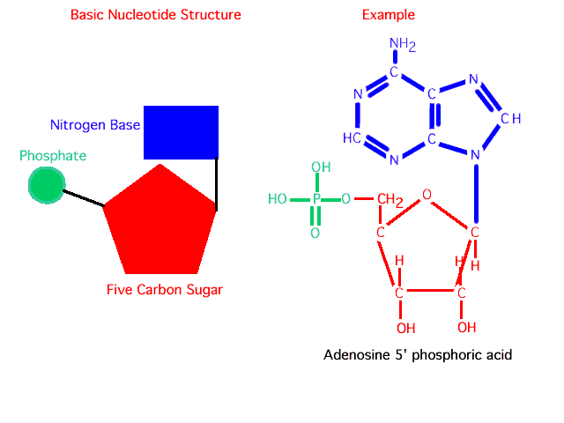
Sugar+phosphate = backbone
- What is a nucleosome? How does it relate to chromatin and histones?
A nucleosome is DNA wrapped around a histone. Nucleosomes condense into chromatin.

- Draw a picture of semiconservative DNA replication. Your picture should show the template strand, the leading and lagging strands, DNA helicase, Okazaki fragments, DNA Polymerase, DNA ligase, the replication fork and the 3’ and 5’ ends of each strand (templates and leading/lagging). Replication should be in the correct direction.
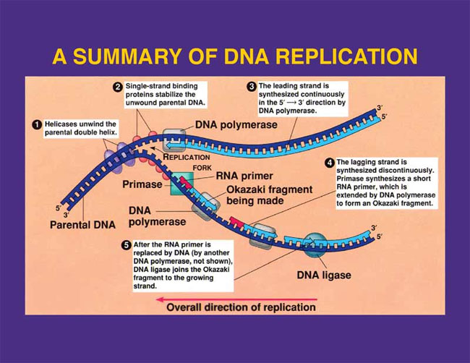
- How are DNA and RNA different? (Three BIG reasons)
Single strand, U instead of T, ribose instead of deoxyribose
- What are the three types of RNA and their jobs?
mRNA, carries message of DNA to the ribosome, tRNA brings the right amino acid to the ribosome by attaching to the mRNA with an anticodon, rRNA associates with proteins to form ribosomes
- Explain the process of TRANSCRIPTION (only). What is RNA polymerase’s role?
DNA is unzipped in the nucleus and RNA polymerase binds to the part of DNA where mRNA will be synthesized. mRNA is synthesized complimentary to the template strand, the strand where RNA polymerase attached. The new mRNA then moves to the cytoplasm.
- What are introns and exons?
Introns (intervening sequences) are pieces of DNA that are like interruptions because they do not end up in the final mRNA. Exons (extracted sequences) are the pieces of DNA that will be made into mRNA
- Explain the process of TRANSLATION (only). How do tRNA, mRNA, and anti-codons play a part?
A specific amino acid , matched by the proper anticodon, is attached to each tRNA by an enzyme. tRNA matches its anticodon to the correct mRNA codon. When the next tRNA matches to its mRNA codon, it adds its amino acid to the forming polypeptide chain. When a STOP codon is reached, the ribosome released the chain.

- What are the mutations discussed in your book and how do they affect protein synthesis?
Point mutations: Only one base pair (A+T or G+C) in a sequence is affected. Some are silent and cause no change. Missense mutations cause the wrong amino acid to be coded for, nonsense mutations cause a stop codon to be coded for.
Insertions or deletions: a base pair is inserted or deleted causing a frameshift. Because DNA is read in groups of three, inserting or deleting a pair will cause the groups to be read differently.
- NOT TESTED

- What might cause mutations?
Mutagens are mutation causing substances that damage DNA. Radiation of many kinds is highly mutagenic.
- How do body cell and sex cell mutations differ?
Sex cell mutations are passed on to future generations, while somatic cell mutations are not.
- What is the central dogma of biology?
DNA is transcribed into RNA. RNA is translated into proteins.
- What is the whole point of transcription and translation?
The purpose is to create new proteins.
- Draw a picture to explain how a cell would transcribe and translate into a protein the following sequence:
TACCCGGTAGACCGTACT
Label: mRNA, amino acid, tRNA, RNA polymerase, transcription, translation, and peptide chain
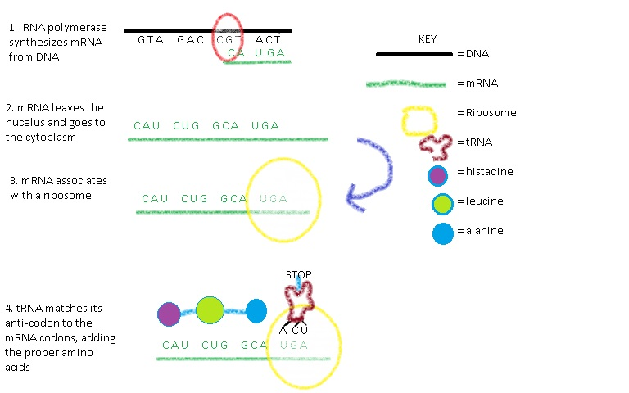

- NOT TESTED
- Operons control whether or not a protein is made.
- NOT TESTED

