Biology Lab Investigation: Cell Theory
Should the unknown microscopic organism be classified as a plant, animal,
or something else?

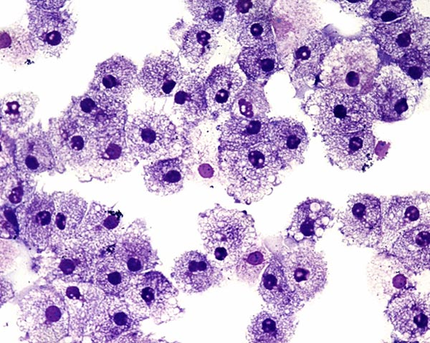
Figure 1. Human cheek cells
Introduction: Plant and animal cells have many organelles in common, including the nucleus, nucleolus, nuclear envelope, rough and smooth endoplasmic reticulum, golgi apparatus, ribosome (free and attached), cell membrane and mitochondria. Some organelles found in plant cells, however, are not found in animal cells and vice versa. For example, animal cells have centrioles (which help organize cell division in animal cells) but plant cells do not. These differences can be used to distinguish between cells that come from a plant and cells that come from an animal.

Your Task: In this investigation you and your group will attempt to classify an unknown microscopic organism based on what you know about the characteristics of plants and animals cells.

The guiding question of this investigation is: Should the unknown microscopic organism be classified as a plant, animal, or something else?

Materials: You may use any of the following materials during your investigation.

- Known Slide A (Plant cells)
- Known Slide B (Plant cells)
- Known Slide C (Animal cells)
- Known Slide D (Animal cells)
- Slide with an Unknown Organism
- Microscope

Safety Precautions: Follow all normal safety rules that apply when working with electrical equipment.

Getting Started: In order to answer this research question you will need to conduct a systematic observation of the cell samples provided. To accomplish this task, you must first determine what type of data you will need to collect, how you will collect it, and how will you analyze it. To determine what type of data you need to collect think about the following questions:

- What type of measurements or observations will you need to make during your investigation?
- How will you quantify any differences or similarities you observe in the different cells?

To determine how you will collect your data, think about the following questions:

- How will you make sure that your data is of high quality (i.e., how will you reduce error)?
- How will you keep track of the data you collect and how will you organize it?

In order to determine how you will analyze your data think about the following questions:

- How will you define the different categories of cells (e.g., what makes a plant cell a plant cell, what makes an animal cell an animal cell, etc.)?
- What type of calculations will you need to make?
- What type of graph could you create to help make sense of your data?

As you work through this activity, be sure to think about how data and evidence are different. Also, think about the different methods that can be used by scientists to answer questions.

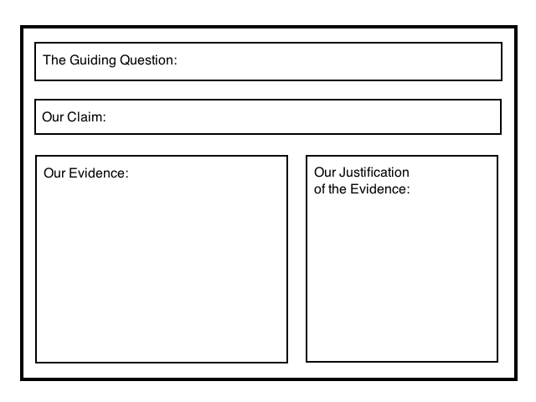
Argumentation Session: Once your group has completed your work, prepare a whiteboard that you can use to share and justify your ideas. Your whiteboard should include all the information shown Figure 1.

To share your work with others, we will be using a Round-Robin format. This means that one member of your group will stay at your work station to share your groups’ ideas while the other group members will go to the other group one at a time in order to listen to and critique the arguments developed by your classmates. When the session is over, you will have a chance to meet with your group and revise your original argument. Figure 1. A whiteboard

Report: Once you have completed your research, you will need to prepare an investigation report that consists of three sections. Each section should provide an answer for the following questions:

- What were you trying to do and why?
- What did you do during your investigation and why did you conduct your investigation in this way?
- What is your argument?

Your report should answer these questions in 2 pages or less. This report must be typed and any diagrams, figures, or tables should be embedded into the document. Be sure to write in a persuasive style; you are trying to convince others that your claim is acceptable or valid!

